LAB 4
You can work on this lab in groups. It is due Monday, October 3, 2016. Hand in only one Lab for your group. Make sure you include everyone’s name on the lab

What happens to the distribution of if the original population is not normal?

In addition to being an important distribution in its own right, the normal distribution can often be used to approximate the probability distributions of other random variables because of the Central Limit Theorem (CLT). The idea of the CLT is that the distribution of sample means (and sums) can be approximated by a normal distribution when sample sizes are large no matter how the individual measurements are distributed!!! The power of this theorem is that as long as one works with ‘large’ sample sizes and is concerned only about making probability statements about the sample mean, the normal distribution can always be used. Many times this result relieves the researcher from worrying about whether the individual measurements follow a binomial, Poisson, or any other special type of distribution.

Central Limit Theorem. Let X denote a measurement drawn from a population with finite mean . If a random sample of n observations is taken from this population, the sample mean, , will be approximately normally distributed with mean when n is large. Therefore, by standardization,

Is distributed as a N(0,1) random variable. Also, the sum of the observations, will be normally distributed with
Problem 1: Data resulting from a study on white rabbit fertility appears in the paper “Genetic analysis of litter traits in Bauscat and Giza white rabbits” (Animal Production (1987): 123-134). For the Giza white rabbit, the mean litter weight is normally distributed with .

- Find the probability that a randomly selected Giza white rabbit has a litter that weighs less than 1900g. (0.5 point)

- Assume that 10% of Giza white rabbits have “large” litters. Find the “borderline” between average and large litters. That is, find such that . (0.5 point)
- Now assume we would like to know if Giza white rabbits being raised on a particular farm have the same population mean litter weight as the “normal” Giza white rabbits. We take a random sample of 16 rabbits from this farm and find their sample mean litter weight to be What is the probability of obtaining a sample mean of 2030 or more if the sample was actually randomly selected from the “normal” population of Giza white rabbits with ? (1 point)
$$P\left(X≥2030\right)=P\left(\frac{X-2000}{\frac{87}{\sqrt{16}}}≥\frac{2030-2000}{\frac{87}{\sqrt{16}}}\right)=P\left(Z≥1.38\right)=1-0.9162=0.0838$$

Is it very likely that we would obtain a sample mean as large (or larger) than what was observed (2030) if the population from which the sample was chosen has a mean of 2000? Therefore, it appears as if there is evidence to believe that the sample of Giza white rabbits from this particular farm comes from a population with a population mean litter weight greater than 2000 g.

Problem 2: The number of accidents per week at a hazardous intersection varies with mean 2.5 and standard deviation 1.4. This distribution is discrete and so is certainly not normal.

- Let be the me an number of accidents per week at the intersection during a year (52 weeks). What is the approximate distribution of according to the central limit theorem? (0.2 point)
- What is the approximate probability that is less than 2? (0.3 point)

- What is the approximate probability that there are fewer than 150 accidents at the intersection in a year? (0.5 point)

Problem 3 (SAS): The characteristics of the Central Limit Theorem can be illustrated by generating samples from a uniform distribution. Using the SAS program below, generate 100 samples of size 10 from a uniform distribution with whole numbers ranging from 0 to 9.
DATA A;
DO SAMPLE = 1 TO 100;
DO UNIT = 1 TO 10;
Y = INT(10*RANUNI(0));
OUTPUT;
END;
END;

Based on these generated data, answer the following:
- How would you expect the data to be distributed?

I would expect the data to be discretely uniformly distributed. In the ideal sense, the data was not discretely uniformly distributed since the observations were random. However, they are close to a discrete uniform distribution because we “simulated” random samples from a discrete uniform distribution.

- Now plot the data using the vertical bar chart with variable Y on the horizontal X-axis and frequency on the vertical Y-axis using the following statements:

PROC CHART DATA=A;
VBAR Y / MIDPOINTS = 0 TO 9 BY 1 LEVELS=10;
RUN;
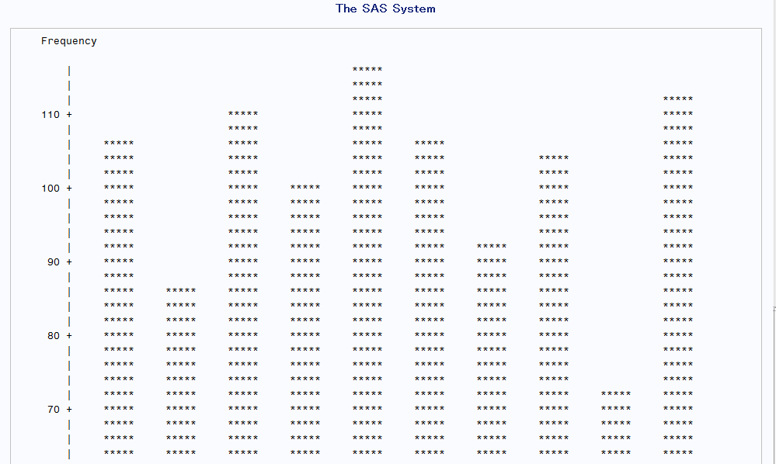

- Were the data actually distributed as you expected?

No. However, they are close to a discrete uniform distribution because we “simulated” random samples from a discrete uniform distribution.

PROC SORT DATA=A;
BY SAMPLE;
RUN;
PROC MEANS DATA=A NOPRINT MEAN STDERR;
VAR Y;
BY SAMPLE;
OUTPUT OUT=NEW MEAN=MYBAR STDERR=SYBAR;
RUN;
PROC UNIVARIATE DATA=NEW NORMAL PLOT;
VAR MYBAR;
RUN;

- How are the sample means distributed? How could the distribution be made more normal?

Normal distribution. It can look more like a normal distribution by increasing the number in each sample.
Tests for Normality
Test | Statistic |  | p Value
Shapiro-Wilk | W | 0.991221 | Pr < W | 0.7624
Kolmogorov-Smirnov | D | 0.048836 | Pr > D | >0.1500
Cramer-von Mises | W-Sq | 0.027205 | Pr > W-Sq | >0.2500
Anderson-Darling | A-Sq | 0.206816 | Pr > A-Sq | >0.2500

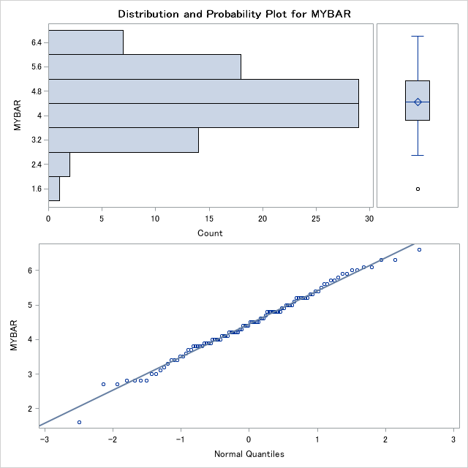

- If you were to construct a 95% confidence interval about the mean using each of the 100 sample means of size 10, how many of them would you expect to contain the true parameter, µ?
Given that the confidence interval are similarly constructed, I would conclude that 95 out of 100 parameter contain the true parameter.
Now, use the following SAS statements to construct a 95% confidence intervals for each of the 100 sample means of size 10 you computed above:
DATA B;
SET NEW;
Z = 1.96;
COUNT = 0;
LCI = MYBAR-(Z*SYBAR);
UCI = MYBAR+(Z*SYBAR);
IF LCI LE 4.5 AND UCI GE 4.5 THEN COUNT = COUNT + 1;
RUN;
PROC PRINT DATA=B;
VAR LCI MYBAR UCI COUNT;
RUN;

- Looking at the printout, how many confidence intervals actually contain the true parameter, µ=4.5?

91 out of 100 intervals contained the actual parameter of 4.5
Problem 4 An agronomist is to conduct a germination study with seeds. What is the probability of at least 95 seeds germinating if each seed has a 0.9 probability of germination? Assume each seed germinates independently. Calculate the probability using

- the normal distribution via the CLT (0.3 point)

- the normal distribution via the CLT with the continuity correction (0.4 point)

- the binomial distribution

Suppose, instead, each seed has a 0.5 probability of germination? Assume each seed germinates independently. Calculate the probability that between 24 and 26 (inclusive) out of 50 seeds germinating using

- the binomial distribution (0.4 point)

- the normal distribution via the CLT (0.3 point)

- the normal distribution via the CLT with the continuity correction (0.4 point)

Based on these probability calculations, can you make a general statement about when the normal
approximation to the binomial distribution works the best? (0.2 point)

The binomial distribution works best using the continuity correction and when π=0.5.

Problem 5: The number of a particular species of bacteria you would expect to find in a milliliter of rumen fluid in a healthy cow is 10. What is the probability of finding more than 5 bacteria in a milliliter sample of rumen fluid using

- the normal distribution via the CLT (0.5 point)

- the normal distribution via the CLT with the continuity correction (0.5 point)

- Poisson distribution

